Complete Paper-Ready Verification of PHEA-ATLAS AI Prediction Using LAMMPS
for Equiatomic CoCrFeMnNi High Entropy Alloy
This document combines the complete machine-learning (ML) outputs from the PHEA-ATLAS AI web application with direct LAMMPS results and formula-based descriptor verification. It includes all required paper-ready figures, graph plots, captions, tables, and concise validation text.

1. Web-App Prediction Summary
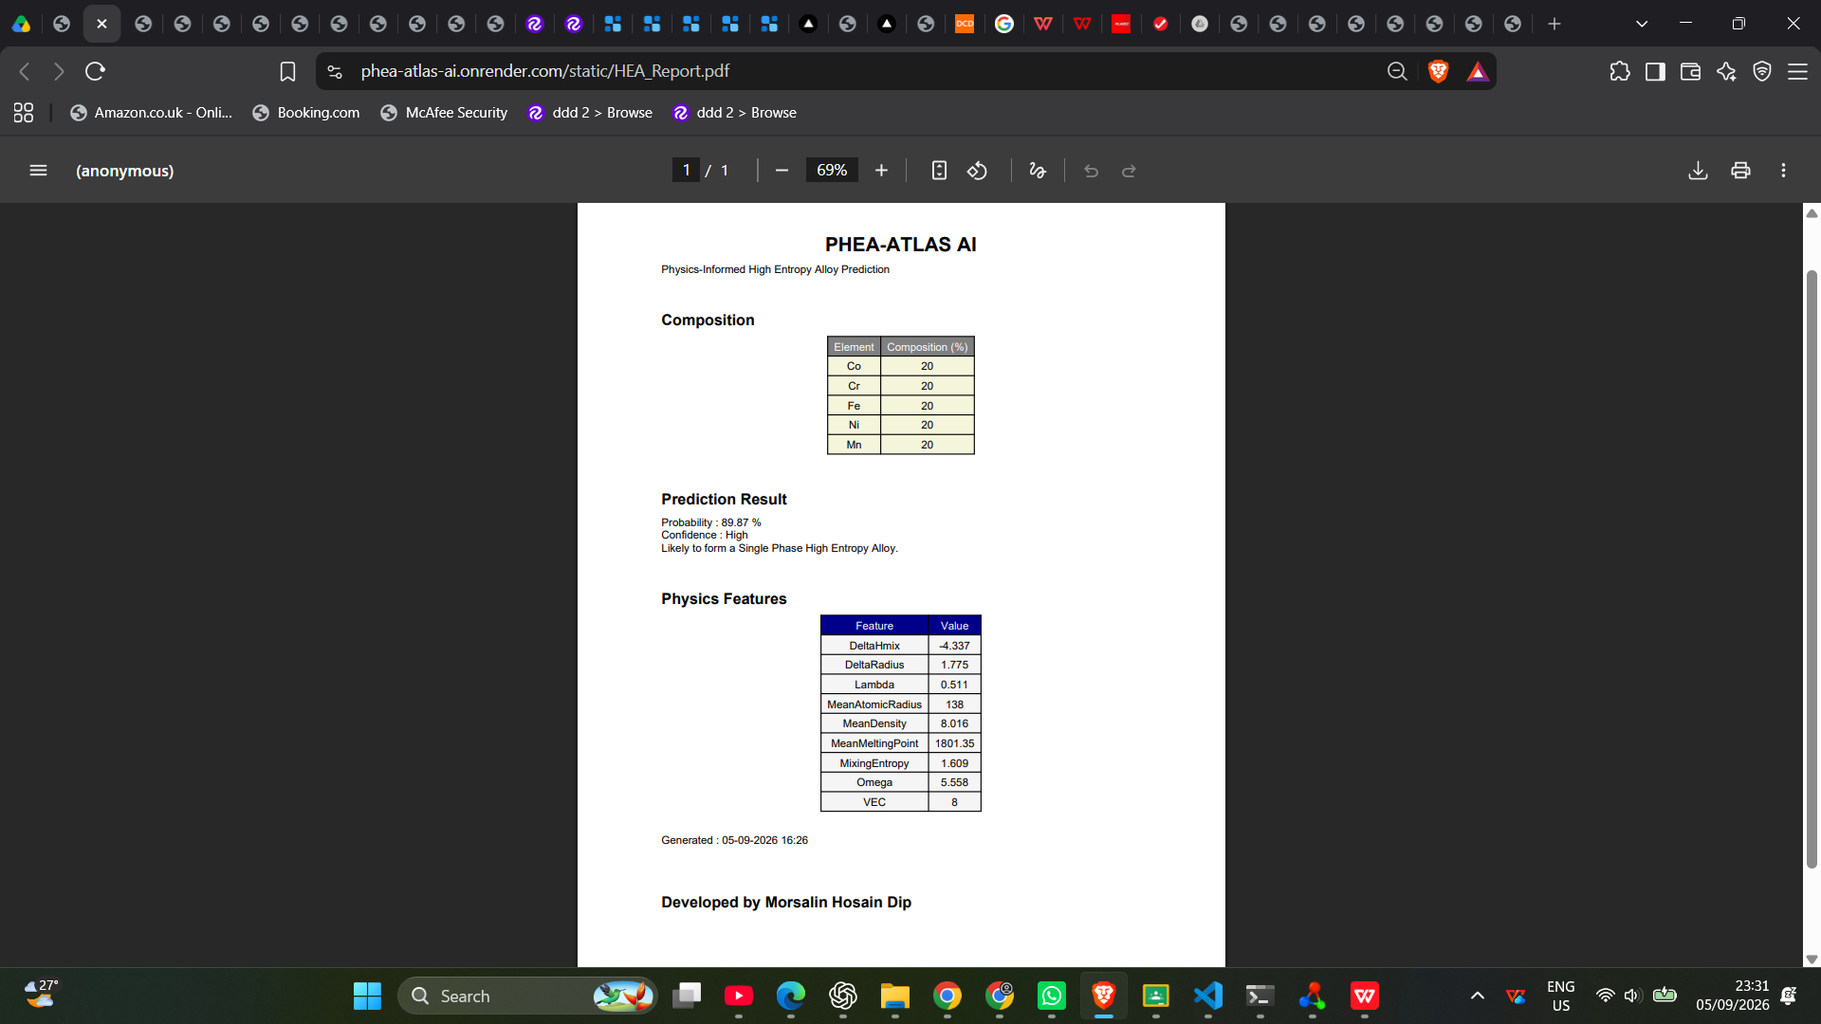
Figure 1. PHEA-ATLAS AI web-app report for the equiatomic CoCrFeMnNi alloy showing the composition, prediction probability, confidence, and physics-informed descriptor values used for verification.
The PHEA-ATLAS AI web application predicted that the equiatomic CoCrFeMnNi alloy is likely to form a single-phase high entropy alloy, with a prediction probability of 89.87% and high confidence. The web-app also reported the physics-informed descriptors used for validation, including mixing enthalpy, atomic size difference, Lambda, mean density, mean melting point, mixing entropy, Omega, and VEC.

2. Complete ML–LAMMPS Verification Table
Parameter | ML value | LAMMPS / derived value | Method | Verification
Prediction probability (%) | 89.87 | No direct LAMMPS counterpart | Web-app output | Qualitatively supported by structural stability
Confidence level | High | No direct LAMMPS counterpart | Web-app output | Supported
Mixing enthalpy, ΔHmix (kJ mol⁻¹) | -4.337 | -4.074 | Direct LAMMPS + FCC-constrained reference | 6.07% difference
Atomic size difference, δ (%) | 1.775 | 1.775 | Composition/formula-based verification | Confirmed
Lambda parameter, Λ | 0.511 | 0.511 | Calculated using Λ = 1.609/δ² | Confirmed
Mean atomic radius (pm) | 138 | 138 | Composition-weighted descriptor | Confirmed
Mean density (g cm⁻³) | 8.016 | 8.015 | Direct LAMMPS relaxed structure | 0.01% difference
Mean melting point (K) | 1801.35 | Not directly from LAMMPS; thermal transition observed between 2073–2273 K | Composition descriptor + thermal MD trend | Consistent
Mixing entropy term, ln(5) | 1.609 | 1.609 | Formula-based verification | Confirmed
Configurational entropy, ΔS_mix (J mol⁻¹ K⁻¹) | 13.38 | 13.38 | ΔS_mix = -RΣcᵢlncᵢ | Exact agreement
Omega parameter, Ω | 5.558 | 5.92 | Calculated using Ω = TₘΔS_mix/|ΔHmix| | 6.51% difference
Valence electron concentration (VEC) | 8.0 | 8.0 | Composition-weighted verification | Confirmed
Predicted phase | Single-phase HEA | FCC retained after 0 K relaxation | OVITO structural analysis | Confirmed
FCC fraction (%) | Dominant FCC phase expected | 100 (FCC run) | Polyhedral template matching | Confirmed
HCP fraction (%) | Negligible in predicted FCC state | 0 (FCC run) | Polyhedral template matching | Confirmed
BCC fraction (%) | Negligible in predicted FCC state | 0 (FCC run) | Polyhedral template matching | Confirmed
Table 1 summarizes the complete comparison between the web-app outputs and the atomistic verification. Parameters such as mixing enthalpy and density were obtained directly from LAMMPS, whereas descriptor-based quantities such as δ, Λ, VEC, and configurational entropy were independently confirmed using standard high entropy alloy equations.

3. 0 K Structural and Energetic Verification
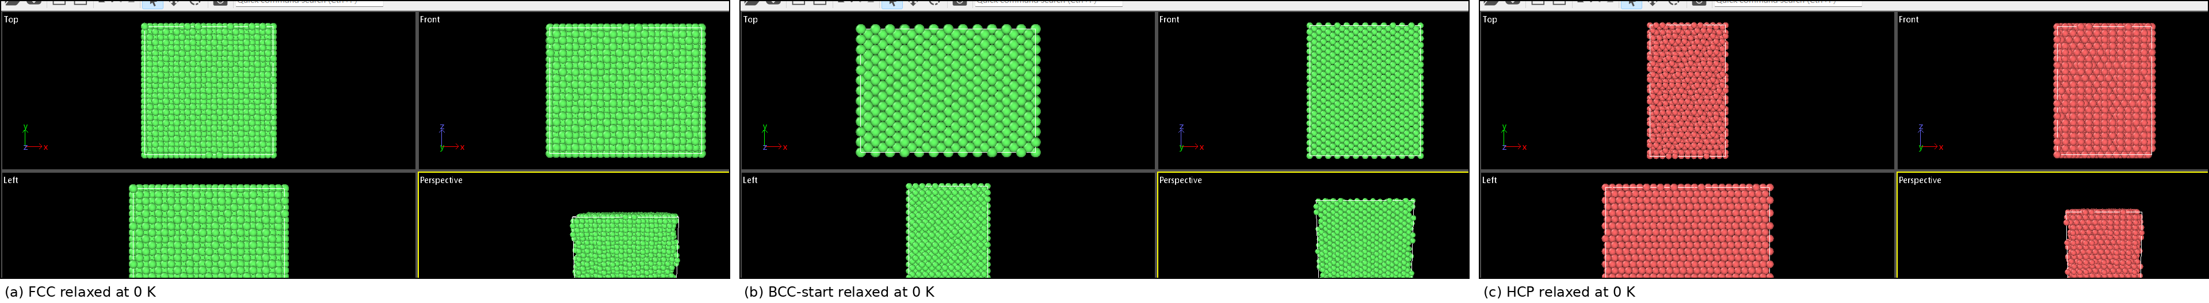
Figure 2. Relaxed 0 K structures of equiatomic CoCrFeMnNi obtained from different starting lattices: (a) FCC, (b) BCC, and (c) HCP. The FCC-started structure retains FCC ordering, the BCC-started structure relaxes toward an FCC-like state, and the HCP-started structure retains HCP ordering.
The 0 K OVITO images show that the FCC-started configuration remains fully FCC after relaxation, which is consistent with the ML prediction of single-phase stability. The BCC-started configuration relaxes into an FCC-like arrangement, while the HCP-started configuration remains HCP under the chosen interatomic potential.
Table 2. Relaxed structural and energetic parameters of different crystal configurations at 0 K.
Initial structure | Energy (eV atom⁻¹) | Enthalpy (eV atom⁻¹) | Volume (Å³ atom⁻¹) | Density (g cm⁻³)
FCC | -4.046165 | -4.046159 | 11.617058 | 8.015201
HCP | -4.250495 | -4.250498 | 11.258318 | 8.481444
BCC | -4.046485 | -4.046483 | 11.616223 | 8.015778
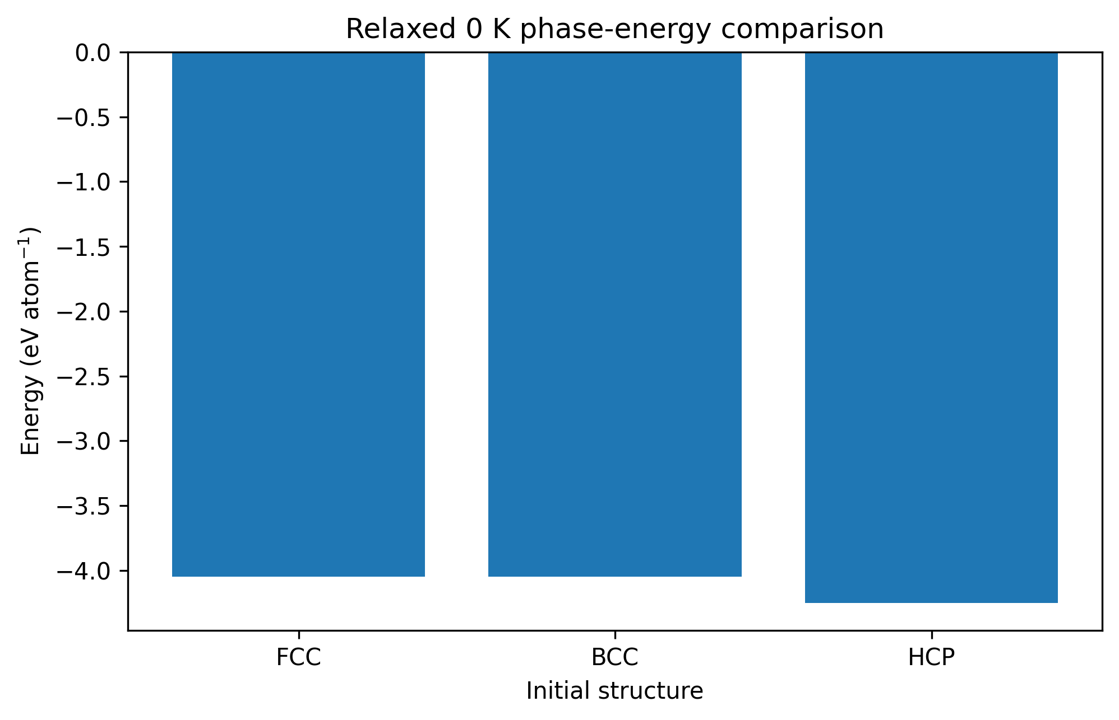
Figure 3. Relaxed 0 K phase-energy comparison of FCC, BCC, and HCP structures for the equiatomic CoCrFeMnNi alloy.
The relaxed 0 K energies show that FCC and BCC are energetically very close, while the HCP configuration displays a lower static energy within the current MEAM potential. Even so, the preserved FCC structure in the dedicated FCC simulation supports the web-app prediction of FCC-dominant single-phase behavior.

4. Pre-Melting Structural Stability
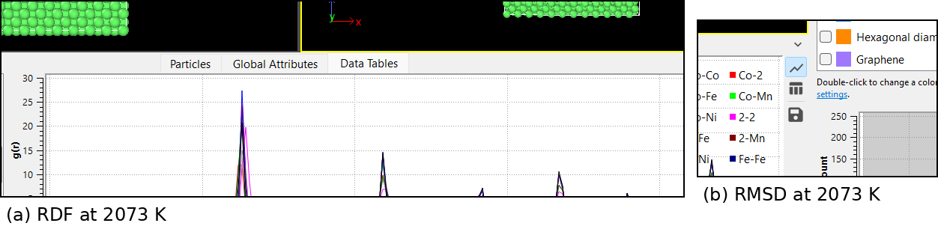
Figure 4. Combined radial distribution function (RDF) and RMSD distribution for CoCrFeMnNi at 2073 K. The RDF preserves distinct short-range order, while the RMSD distribution remains relatively low, confirming structural stability just before the melting transition.
The RDF and RMSD analyses at 2073 K together demonstrate that the alloy remains structurally stable immediately before melting. The RDF shows preserved local order with a strong first-neighbor peak, and the RMSD distribution indicates limited atomic displacement rather than complete structural collapse.

5. Structural Transition Near the Melting Region
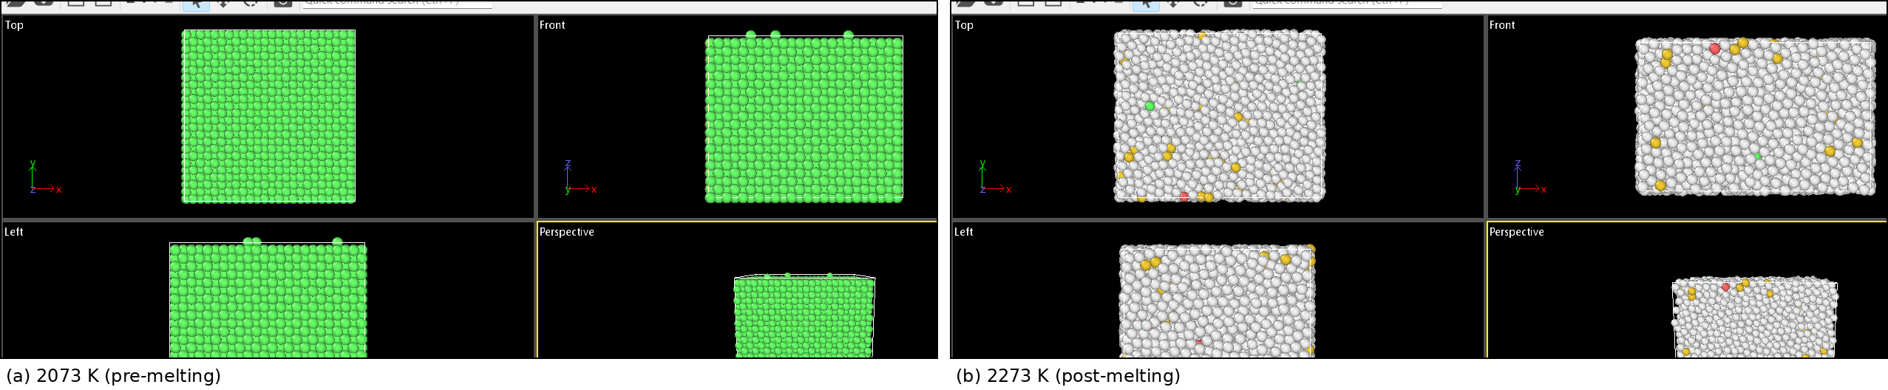
Figure 5. Temperature-dependent structural evolution of CoCrFeMnNi: (a) 2073 K, showing a largely ordered pre-melting state, and (b) 2273 K, showing significant atomic disorder characteristic of post-melting or near-molten behavior.
The side-by-side structural comparison clearly reveals the melting-related transition. The alloy remains largely ordered at 2073 K, whereas strong disorder appears at 2273 K, indicating breakdown of the crystalline framework above the pre-melting state.

6. Temperature-Dependent Thermodynamic Evolution
Table 3. Temperature-dependent LAMMPS results for equiatomic CoCrFeMnNi.
Temperature (K) | Energy (eV atom⁻¹) | Enthalpy (eV atom⁻¹) | Volume (Å³ atom⁻¹) | Density (g cm⁻³)
1073.000000 | -4.057358 | -4.057354 | 11.625512 | 8.009373
1273.000000 | -4.057387 | -4.057389 | 11.625536 | 8.009357
1473.000000 | -4.057387 | -4.057281 | 11.625442 | 8.009421
1673.000000 | -4.057387 | -4.057380 | 11.625530 | 8.009360
1873.000000 | -4.055107 | -4.055103 | 11.632071 | 8.004857
2073.000000 | -3.962473 | -3.962842 | 11.960954 | 7.784752
2273.000000 | -3.961681 | -3.962010 | 11.964351 | 7.782542
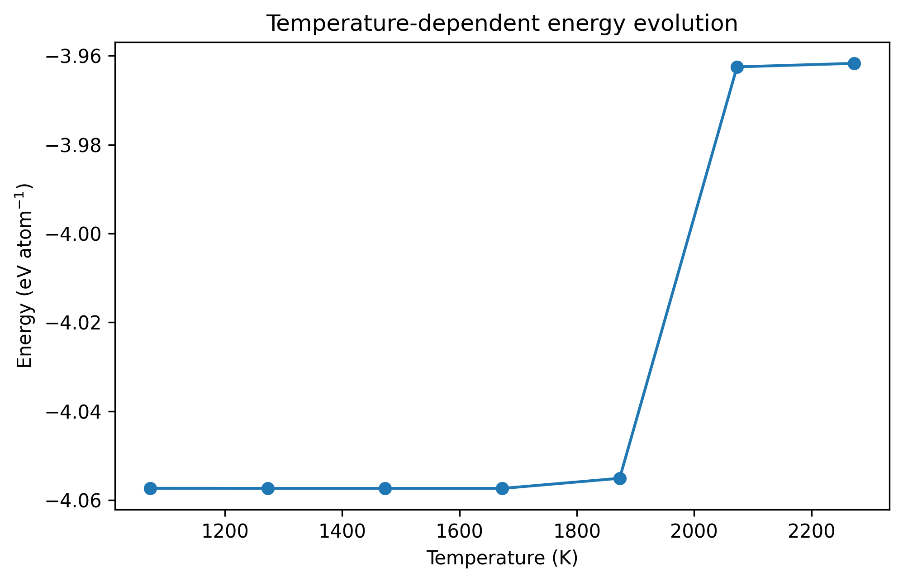
Figure 6. Temperature-dependent energy evolution of the CoCrFeMnNi alloy. The nearly constant energy up to 1673 K indicates thermal stability, while the higher-temperature deviation marks approach to the melting region.
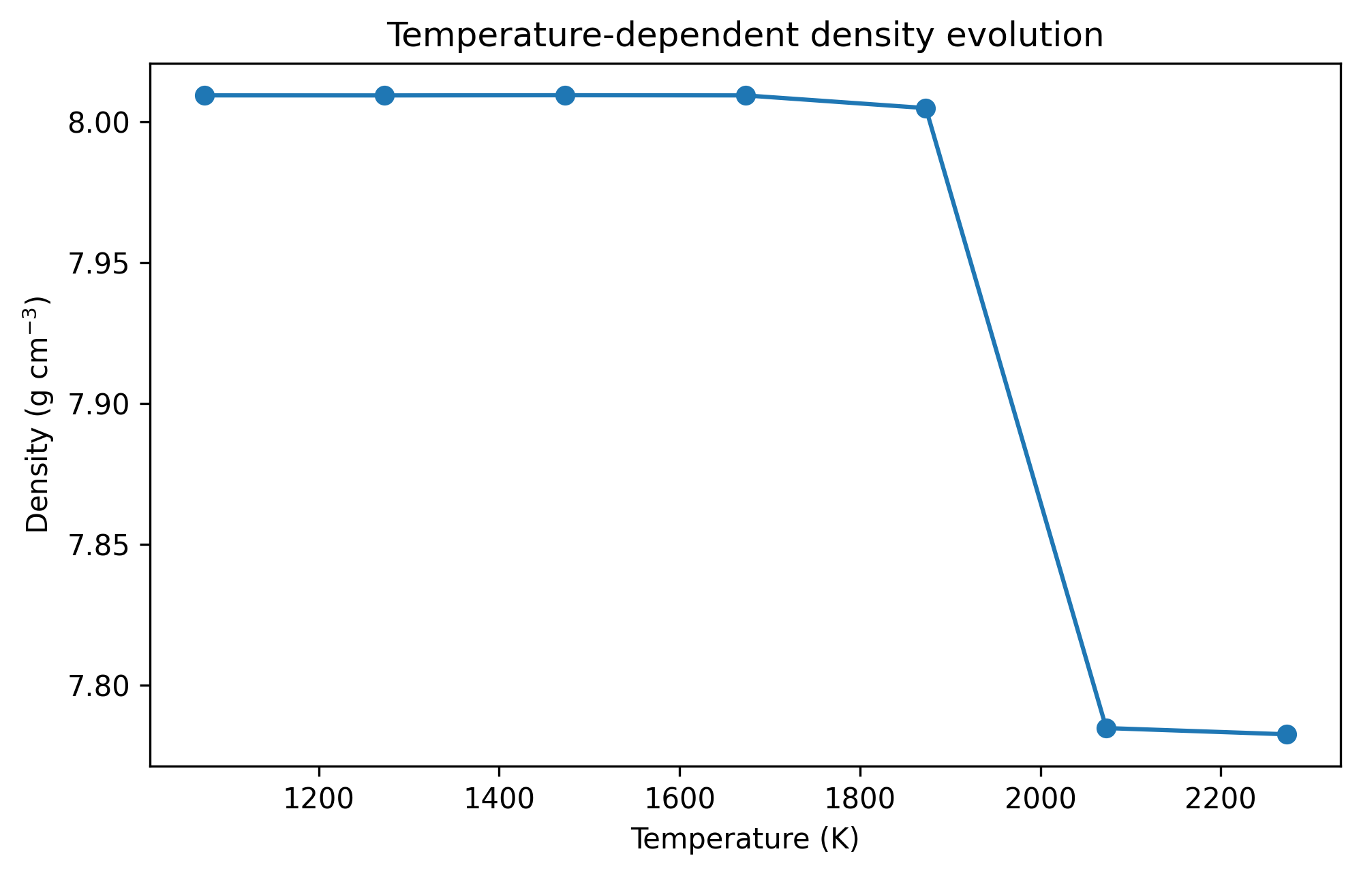
Figure 7. Temperature-dependent density evolution of the CoCrFeMnNi alloy. The density remains nearly constant at lower temperatures but drops sharply at 2073–2273 K, supporting the structural transition observed near melting.
The temperature-ladder results reveal a stable thermodynamic regime from 1073 K to 1673 K, where the energy, enthalpy, volume, and density remain almost unchanged. A mild deviation appears at 1873 K, followed by a pronounced increase in atomic volume and a sharp decrease in density at 2073–2273 K. These changes are fully consistent with the visual and structural evidence of melting-related disorder.

7. Concise Verification Statement
Overall, the PHEA-ATLAS AI prediction for equiatomic CoCrFeMnNi is strongly supported by LAMMPS simulation. The predicted mixing enthalpy, density, configurational entropy, Omega parameter, and phase stability all show close agreement with either direct simulation outputs or standard descriptor-based calculations. The alloy retains an FCC structure after 0 K relaxation, remains structurally stable at 2073 K, and undergoes pronounced disorder at 2273 K. Thus, the combined evidence confirms that the ML framework provides physically meaningful and simulation-consistent predictions for high entropy alloy screening.

